

**American International University-Bangladesh (AIUB)**

**Faculty of Science and Technology (FST)**

**Department of Computer Science (CS)**

**SDPM Group Project, Spring 2023**

**Project Title:** **Travel Management System**

**Section: D**

**Submitted by**

|  |  |
| --- | --- |
| Name | ID |
| MOINUL ISLAM | 20-42390-1 |
| SHARIAR NIHAL | 20-43220-1 |
| TAPASH CHANDRA DABNATH | 18-39185-3 |
| FATEMA AFRIN | 19-41294-3 |

1. **Introduction:**

Nowadays, people rely heavily on the internet for various services, including traveling. The COVID-19 pandemic has shown us the benefits of doing things online. In Bangladesh, we want to create a web-based platform that will bring together both travelers and transportation businesses. This platform will have many features, such as showing statistics on different destinations and their costs. With this information, travelers can make informed decisions about where to go and how much they can spend. They can also book tickets, cars, or lodging right from the platform. The platform will allow travelers to communicate with tour companies and property owners, and businesses such as hotels, buses, cars, trains, and airplanes can use it too. As we want to make sure that the platform is useful to everyone, we'll keep updating it based on user feedback.

**2.0 Project Title**:

The title of our project is the travel management system. It basically is a web-based application that aims to combine the services desired by tourists as well as travel-related business organizations.

**3.0 Objectives:**

The Travel Management System is a website that makes it easy for people who want to travel in Bangladesh to find information about destinations, transportation, and lodging options. It also helps businesses in the travel industry to connect with customers.

On the website, users can search for information about different districts in Bangladesh, such as popular tourist spots and estimated costs. They can also book transportation, tickets, and lodging based on their budget.

The goal of the website is to become the go-to source for travel-related information and services in Bangladesh. It aims to simplify the travel process for both customers and businesses. The mission is to provide comprehensive information about all districts of Bangladesh, offer a variety of travel-related services, and help entrepreneurs in the travel industry connect with their clients. Ultimately, the website hopes to promote tourism in Bangladesh and make travel easier for everyone involved.

**4.0 Justification:**

Travel Management System is very beneficial for the travel

business. Some of the benefits are mentioned below:

* It greatly facilitates work organization.
* The payment mechanism is simple and secure.
* It facilitates task reduction for the management team.
* This system will provide a display platform where a tourist can find their tour places according to their choices.
* Customers may make bookings at any time or cancel bookings within the given deadline.
* This system will connect customers and agents directly through the Internet.
* This system gives a variety of travel services that will sure to match all client’s priorities.
* This system will provide a display platform where a tourist can find their tour places according to their choices.

**5.0 Systems Overview:**

In this application, there will be four types of users. They are tourists, business owners, administrative team members, and the system itself. Subscribed tourists will be a specialized type of user who will have access to ad-free experiences and discounts. Tourists will be able to search travel destinations, choose routes, and book hotels and transportation or other community services. Business owners will be able to add business details and pay the due amount to the platforms. Admins will be in charge of keeping track of the payments and verification of users. The system will coordinate communication between tourists and business owners, analyze and recommend destinations, and maintain history. The overview of our system is shown below through a use case diagram:

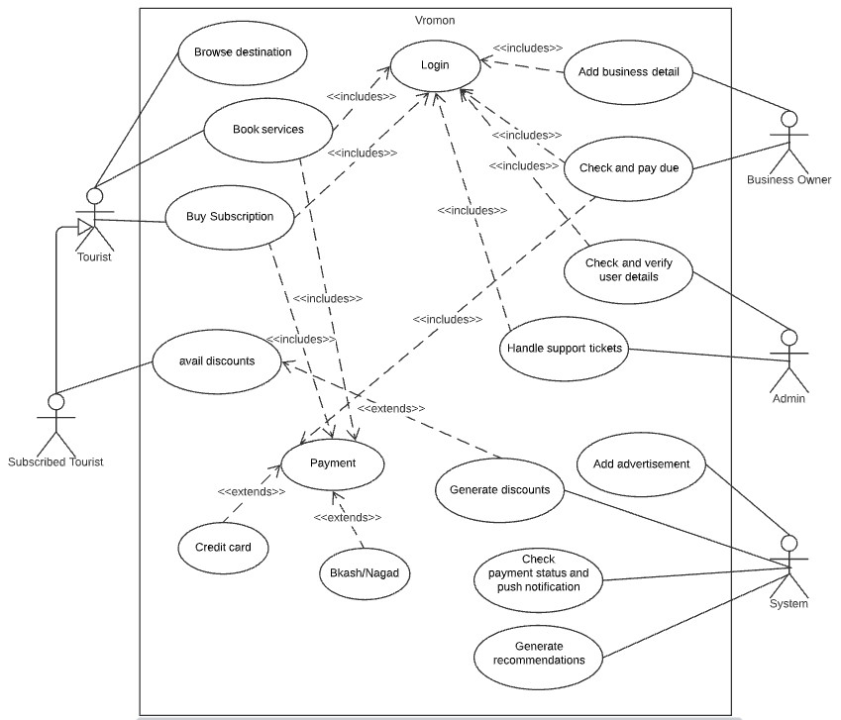

**Figure : Use Case Diagram**

**6.0 Stakeholders Analysis:**

There are two categories of stakeholders in our system. Internal stakeholders come first, followed by external stakeholders.

* **Internal Stakeholder:** Internal stakeholders are a group of persons who are employed directly by the company. Our system's internal stakeholders are:

1. Employee: The employee will be the primary internal stakeholder. because workers invest a lot of time and money in the business and are essential to its operations, strategy, and tactics.

2. Manager: Managers are internal stakeholders since workers have an interest in the success of the business because it affects their capacity to be paid and keep their jobs. Depending on the nature of the organization, employees may pay different attention to health and safety.

3. Developer: With their technical expertise, they may advise executives on which features are feasible and how long each would take to develop.

* **External Stakeholder**: External stakeholders are those who don't directly work for a company but nonetheless have an impact on its choices and outcomes.

1. Vendors: Vendors provide the parts or raw materials a business requires to produce its goods. A business may be reliant on a single source who produces an exceptional or rare good; in this case, the supplier is crucial.

2. The government is an external shareholder in every company. It is actually recognized as one of the main stakeholders because it collects taxes from these enterprises in the form of corporate income tax and income tax from the company's employees.

3. Customer: Customers may be thought of as the most important external stakeholders. These are the people who will make use of the company's services or final products. Therefore, even if they are not involved in the day-to-day operations of the firm, they determine whether it will succeed or fail.

**7.0 Feasibility Study:**

The preliminary investigation looks at the project's viability and the likelihood that the system will be beneficial to the business. The main objective of the feasibility study is to establish the technical and financial viability of adding new modules and correcting existing systems. All systems are conceivable if given an infinite amount of time and resources. The following components make up the feasibility study for the preliminary investigation:

Technical Feasibility and Economical Feasibility.

* Technical Feasibility: During the feasibility phase of the inquiry, the following technical issues are typically raised:
  + Is the technology available to execute the suggestion?
  + Can the proposed hardware technically store the data required to run the new system?
  + Would the suggested system be able to appropriately respond to requests regardless of user volume or location?
  + Can the system be upgraded if it is created?
* Economical Feasibility: Technically speaking, a system can be built, but the business must still think it is a smart investment. In the financial feasibility analysis, the system development expenses are weighed against the eventual advantages of the new systems. Benefits must be equal to or greater than costs in terms of money. The system can function equally well. There is no need for additional gear or software.

**8.0 System Components:**

Three different users kinds will use this application. As follows:

1. Travelers who will:

• Look up information on various vacation spots.

• Use a variety of travel services.

• Possibility of purchasing a premium membership.

1. Owners of travel businesses will

• List their establishments for travelers.

• There might be several businesses listed.

• Pay a percentage of the payment from the tourists to the system.

3. A member of the administrative staff who will

• Use the E-Trade License and ETIN numbers to the legitimacy of the firms.

• Have access to reservation information.

• When required, access customer or business information.

• Work together to find solutions to user account-related problems.

**Features:** The application will include but is not limited to the following features:

* + - Travel destination information based on districts
    - Travel location suggestion based on popularity
    - Search options based on districts
    - Options for selecting different travel services
    - Ticketing based on cost, type, and routes
    - Subscription for a premium membership
    - Special offers and discounts
    - Option to list business for business owners
    - Payment method selection
    - Travel and booking history

**9.0 Process Model to be Followed:**

SDLC (Spiral Model):

The Software Development Life Cycle is what it stands for. It is a standard that the software industry uses to create high-quality software.

**Stages in SDLC:**

* Requirement Gathering
* Analysis
* Designing
* Coding
* Testing
* Maintenance

**10.0 Effort Estimation:**

The average KLOC (thousand lines of code) for finishing such a system while taking the programming language into account is 100.

The COCOMO 2 approach can be used to determine the number of person-months required for the project.

Effort = PM=Coefficient<Effort Factor> *(SLOC/1000) ^P

=3*(100,000/1000) ^1.12

=521 person months

Here,

Coefficient<Effort Factor> = 3 (as the project is a Semi-detached project)

SLOC (Source Line of Codes) = 100,000

P = 1.12 (as the project is a Semi-detached project)

Given that the agile technique was selected for the project's completion, it was determined that 66 working days would be needed to finish the project after taking effort estimation into consideration. The time phase for each task can be broken down into the following categories based on the Rational Unified Process:

|  |  |
| --- | --- |
| **Task of phase**  **Days** | **Person Month** |
| Requirements Elicitation 08 | 64 |
| Project Planning 11 | 88 |
| Requirements Analysis 08 | 64 |
| System Design 12 | 96 |
| Object Design 10 | 80 |
| Implementation & Unit Test 08 | 64 |
| System Integration & System Testing 09 | 54 |

**Note:** Every engineer works 8 hours a day, 5 days a week. The overall length of the project is 66 working days, (excluding national holidays).

So, the required development time can be calculated as follows:

DM = 2.50*(PM) ^T

= 2.50*521^0.35

= 22 months

Here,

PM = Person-months need for the project= 521 person months

T = 0. 35 (as the project is a Semi-detached project)

And, the required number of people

ST = PM/DM

= 521/22

= 23 peoples

Here,

PM = Person-months need for the project (Labour working hour) = 521 hours

DM = Development time = 22 hours

The project's estimated total cost is as follows:

• 521 person months are needed to complete it;

• 22 months are needed for development;

• 23 individuals are needed overall.

**11.0 Activity Diagram:**

The system will determine the user type during login. The system identifies whether or not the user is a subscriber or a tourist. Discounts will be given to subscribers, and no advertisements will be shown. Any user is able to browse different locations and book services. Business owners have the power to add, update, or remove their products or services. Additionally, they will be informed of business opportunities and the progress of their payments. Administrators will be able to reply to user support tickets and verify user information given by business owners.

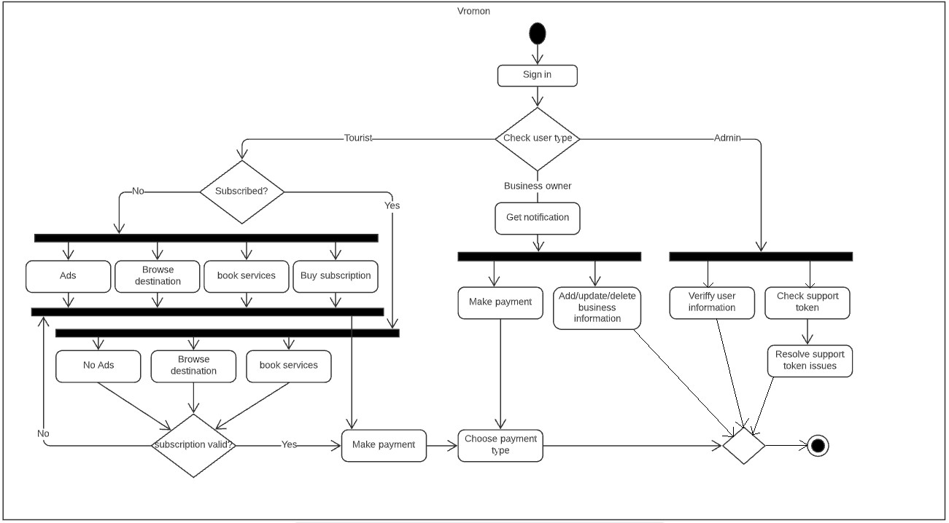

Figure: Activity Diagram

**12.0 Risk Analysis:**

|  |  |  |  |  |
| --- | --- | --- | --- | --- |
| **Risks** | **Probability** | **Impact** | **Rating** | **RMMM** |
| Project Manager Availability | 20% | 3 | Medium | R-1 |
| Schedule slips | 40% | 1 | High | R-2 |
| System goes hour | 50% | 3 | Medium | R-3 |
| Project cancelled | 40% | 4 | Low | R-4 |
| Programmers doesn’t have good experience | 30% | 3 | Medium | R-5 |
| Late delivery | 50% | 3 | Medium | R-6 |
| Customer Participation in Beta Testing | 30% | 4 | Low | R-7 |

**13.0 Budget for the project:**

Description Cost Assumptions

Site launch (hosting)= 10,000 BDT

Maintenance (1 year)= 25,000 BDT

Developers= 1,00,000 BDT

Grand Total= 1,35,000 BDT

So from the above calculation

Total Budget is = 1, 35,000 BDT

**14.0 Conclusion:**

Finally, after a project module has been completed or executed, we will gather user feedback. Security should be a feature of travel management system software. When it comes to this project's customer iterations with hotels and travel agents, project management must accurately measure, objectively distinguish, and assign tasks. Given the overall project deadline of nine to ten months, maintaining focus and finishing the work on time is the most challenging aspect of this project. Nowadays, people look up travel-related information online because it is the quickest and most convenient way to do so. In Bangladesh, there are several Internet travel agencies. A web-based platform that offers both visitor and travel-related business entity services is the approach we envisage taking. As a hosting platform, it will serve hotel or property owners as well as owners of buses, vehicles, trains, and airplanes, so it is not just for tourists.